THE UNIVERSITY OF AZAD JAMMU & KASHMIR
DEPARTMENT OF SOFTWARE ENGINEERING

Student Name | Syed Muhammad Hassan Gillani | 
Roll Number | 2024-SE-42
Course Name | Software Construction & Development
Course Code | SE-3101
Session | 2024-2028 (BS SE - 5th Sem)
Department Name | Department of Software Engineering
Task / Assignment No. | Lab Task #04
Instructor Name | Engr. Dr Asma Javed
Submission Date | November 01, 2026
Topic / Title | Class Diagrams & C++ OOP Implementation
Question 1: Online Doctor Appointment Management System
Problem Statement Analysis:
Design a real-world Online Doctor Appointment Management System where patients create accounts to apply for hospital/clinic appointments. Doctors view requests and accept/reject them based on schedule availability. On acceptance, confirmation notifications are dispatched to patients.
Identification & Explanation of System Classes
- User (Base Class): Represents generic platform user entities. Attributes include userId, name, email, and phone. Contains core authentication logic like createAccount() and login().
- Patient (Subclass of User): Inherits from User. Represents patients seeking consultations. Contains medicalHistory and methods requestAppointment() and viewStatus().
- Doctor (Subclass of User): Inherits from User. Represents healthcare specialists. Attributes include doctorId, specialization, and clinicAddress. Methods include acceptAppointment(), rejectAppointment(), and updateSchedule().
- Appointment (Entity Class): Encapsulates booking data including appointmentId, date, timeSlot, and status (Pending/Confirmed/Rejected). Methods handle confirmation and cancellation.
- Schedule (Control Class): Manages availability calendar slots for a doctor. Attributes include scheduleId and availableSlots. Methods check free slots and mark time slots as busy.
- Notification (Utility Class): Handles communication alerts. Formats and sends confirmation or cancellation SMS/emails to patients once an appointment decision is finalized.
UML Class Diagram
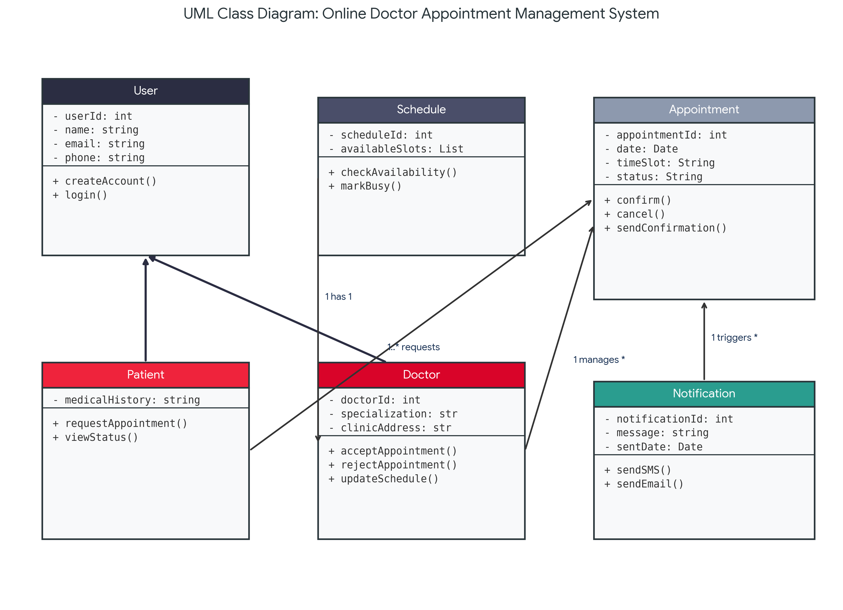
Figure: UML Class Diagram for Online Doctor Appointment Management System
Diagram Relationships Explanation
- 1. Generalization (Inheritance): Patient and Doctor classes extend the parent User class, inheriting common properties.
- 2. Association (Patient -> Appointment): Patient creates one or more (1..*) appointment requests.
- 3. Association (Doctor -> Schedule): Each Doctor maintains exactly 1 Schedule object to manage time slots.
- 4. Association (Doctor -> Appointment): Doctor reviews and accepts/rejects multiple (*) appointment requests.
- 5. Dependency / Association (Appointment -> Notification): Appointment status updates trigger confirmation notifications.
Question 2: Animal Superclass with Cat and Dog Subclasses
Problem Requirements: Implement superclass Animal with subclasses Cat and Dog. Animal can eat and sleep. Cat meows, Dog barks. Draw class diagram and write C++ code.
UML Class Diagram
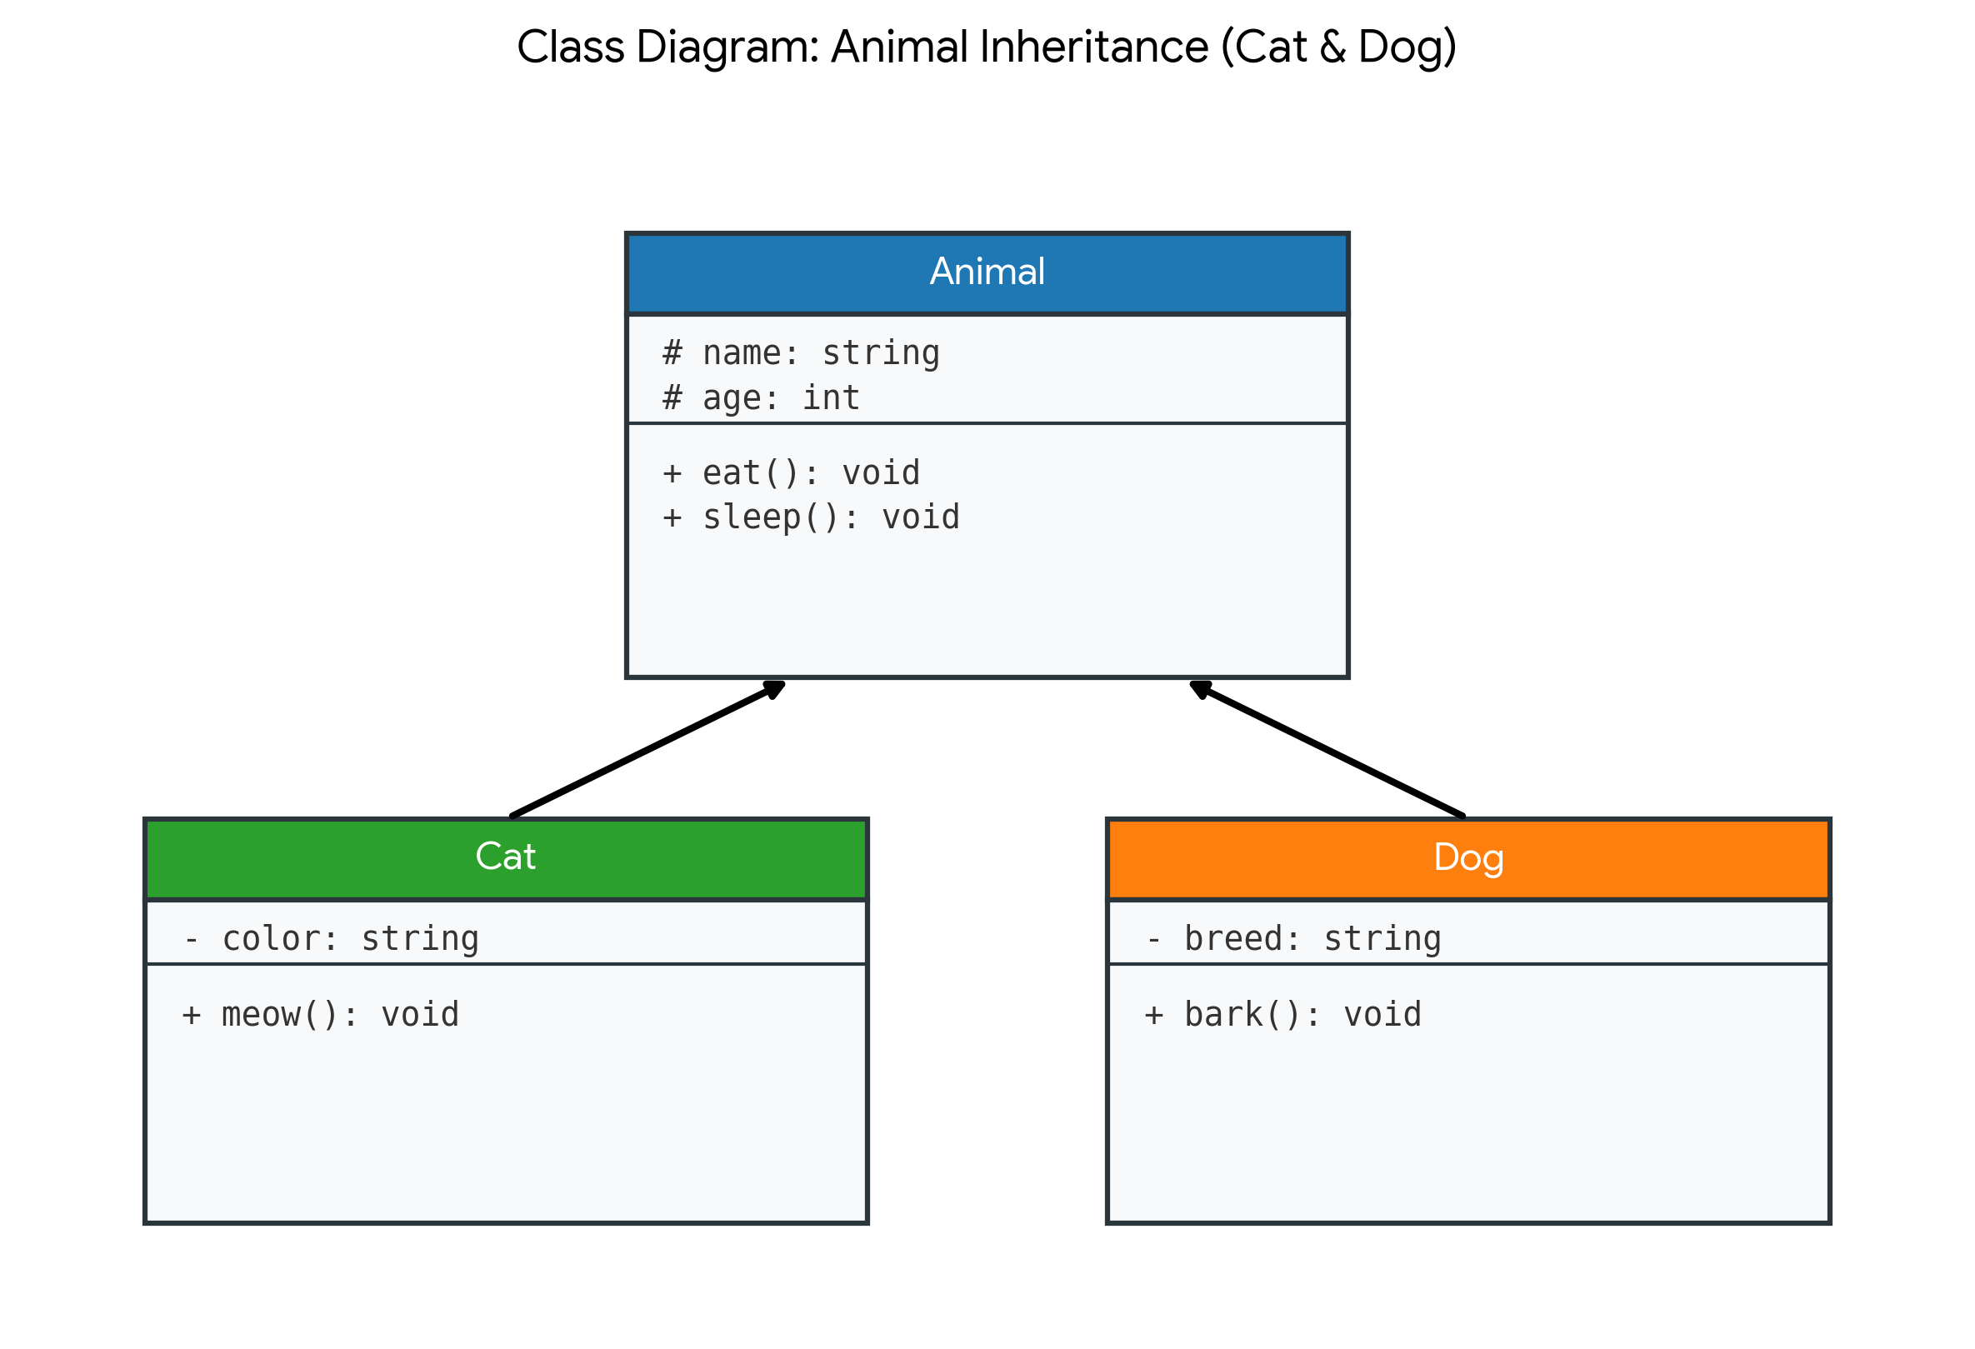
Figure: UML Class Diagram for Animal Inheritance (Cat & Dog)
C++ Source Code Implementation
#include <iostream>
#include <string>
using namespace std;
// Base Class: Animal
class Animal {
protected:
string name;
int age;
public:
Animal(string n = "Unknown", int a = 0) : name(n), age(a) {}
void eat() {
cout << name << " is eating food peacefully." << endl;
}
void sleep() {
cout << name << " is resting and sleeping." << endl;
}
};
// Derived Class: Cat
class Cat : public Animal {
private:
string color;
public:
Cat(string n, int a, string c) : Animal(n, a), color(c) {}
void meow() {
cout << name << " (a " << color << " cat) says: Meow! Meow!" << endl;
}
};
// Derived Class: Dog
class Dog : public Animal {
private:
string breed;
public:
Dog(string n, int a, string b) : Animal(n, a), breed(b) {}
void bark() {
cout << name << " (a " << breed << " dog) says: Woof! Woof!" << endl;
}
};
int main() {
cout << "=== OOP Inheritance Demonstration: Animal System ===" << endl << endl;
Cat myCat("Whiskers", 3, "White");
Dog myDog("Buddy", 5, "Golden Retriever");
cout << "--- Cat Actions ---" << endl;
myCat.eat();
myCat.sleep();
myCat.meow();
cout << endl << "--- Dog Actions ---" << endl;
myDog.eat();
myDog.sleep();
myDog.bark();
return 0;
}

Question 3: Shape Class Hierarchy (Triangle & Rectangle Area Calculation)
Problem Requirements: Implement superclass Shape with derived classes Triangle and Rectangle. Calculate area based on user input. Draw class diagram and write C++ code.
UML Class Diagram
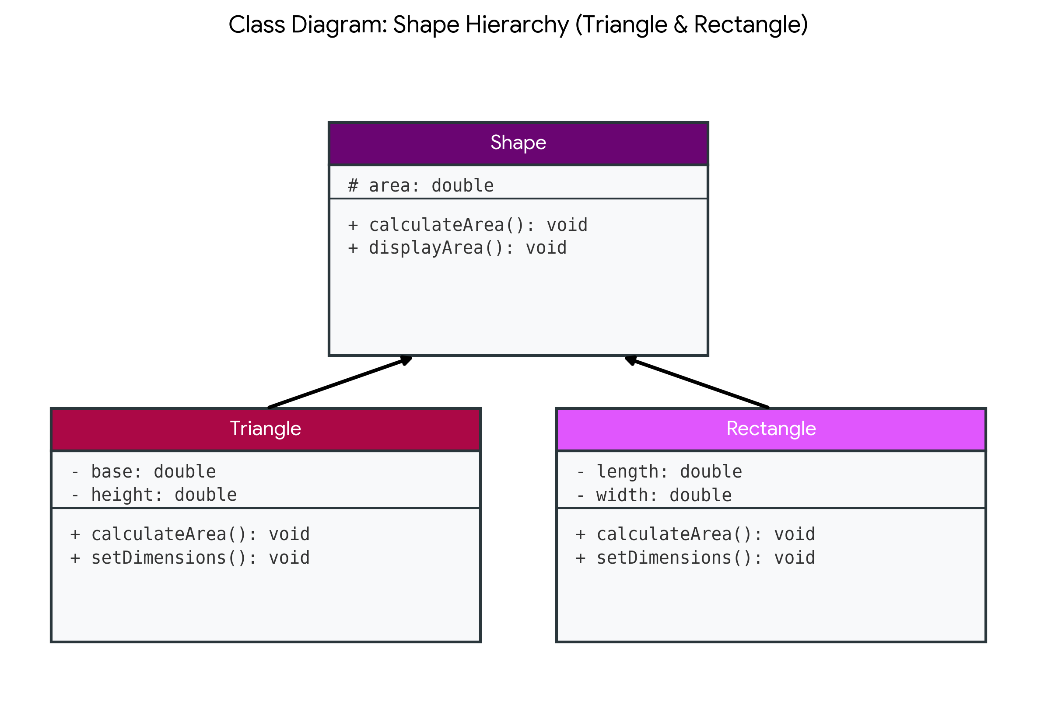
Figure: UML Class Diagram for Shape Hierarchy
C++ Source Code Implementation
#include <iostream>
#include <iomanip>
using namespace std;
// Base Class: Shape
class Shape {
protected:
double area;
public:
Shape() : area(0.0) {}
virtual void calculateArea() {
area = 0.0;
}
void displayArea() const {
cout << "Calculated Area: " << fixed << setprecision(2) << area << " sq units" << endl;
}
};
// Subclass: Triangle
class Triangle : public Shape {
private:
double base;
double height;
public:
Triangle(double b = 0.0, double h = 0.0) : base(b), height(h) {}
void setDimensions(double b, double h) {
base = b;
height = h;
}
// Area of Triangle = 0.5 * base * height
void calculateArea() override {
area = 0.5 * base * height;
}
};
// Subclass: Rectangle
class Rectangle : public Shape {
private:
double length;
double width;
public:
Rectangle(double l = 0.0, double w = 0.0) : length(l), width(w) {}
void setDimensions(double l, double w) {
length = l;
width = w;
}
// Area of Rectangle = length * width
void calculateArea() override {
area = length * width;
}
};
int main() {
cout << "==========================================" << endl;
cout << " SHAPE AREA CALCULATOR (OOP C++) " << endl;
cout << "==========================================" << endl << endl;
double b, h, l, w;
// Triangle Input
cout << "--- Triangle Calculations ---" << endl;
cout << "Enter Base of Triangle: ";
cin >> b;
cout << "Enter Height of Triangle: ";
cin >> h;
Triangle tri;
tri.setDimensions(b, h);
tri.calculateArea();
tri.displayArea();
cout << endl << "--- Rectangle Calculations ---" << endl;
cout << "Enter Length of Rectangle: ";
cin >> l;
cout << "Enter Width of Rectangle: ";
cin >> w;
Rectangle rect;
rect.setDimensions(l, w);
rect.calculateArea();
rect.displayArea();
cout << endl << "==========================================" << endl;
return 0;
}

